WING SERVO MOUNTING
My favorite way of mounting wing servos.....it allows for easy removal and adjustent, keeps the servo clean and out of sight and it is easy to do with shop materials.....nothing to buy.
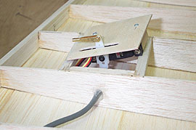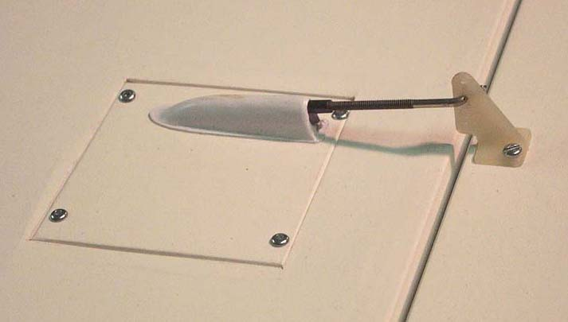

I like to make make a small lightply door mounted into the wing with four screws. Cover it with the matching covering material. Two plywood blocks are glued onto the inside of the door and the servo screwed onto them. The servo arm protrudes through a slot in the door and the usual pushrod connection is made to the horn on the outside. The outward appearance is clean and flush with the wing surface. The small plastic covers over the slot are vacume formed to suit the location of the pushrod connector and the servo arm.
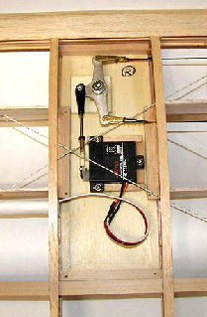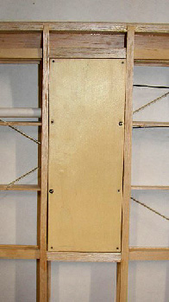

In the above picture a single flat-wing servo and a pull-pull belcrank are mounted on
the back of the plywood door. The door will be covered with the same fabric as the
wing itself and very little will be visible from outside. In this case the wing is very thin and I wanted everything to be hidden.

Ray McDougall
2009

