Windows for Models
Ray McDougall

Cutting windows into the fuse, setting in the "glass" and making the proper bezel around the glass can be a real pain.....Most that I've seen don't' really look very good and most of us don't need "museum scale " quality anyway. I use homemade decals, it's simple and looks good.
The decals can be made on your computer using only Microsoft Word.....no special programs are necessary. Once the artwork is done I print with my inkjet printer onto waterslide decal paper and transfer them to the model. Clearcoating may be necessary if they will be near fuel contamination.

Here is how to use Word to create the artwork.....
- Open new blank page in Microsoft Word.
- Go to “INSERT”, open the “SHAPES” tab…..a box will appear where you can create your drawing. Click on the shape that you want under “BASIC SHAPES”.
- Place your curser in the box, left click and drag out the shape and size of the window that you want.
- Now open the ”SHAPE OUTLINE” tab and select the color and thickness of line that you like.
- Now click the “SHAPE FILL” tab and select the fill color and gradient that you want. ……play with these to get the right effect. Under “MORE GRADIENTS” at the bottom of the window, set one or two colors, the transparency and the shadow style.
- Finally, save the finished product for printing. The size of the window can be altered in the printing process and the windows can be stepped out on the page to print dozens of them on one sheet.
- Print on white or transparent waterslide decal paper for application on the model.

Here are some samples....

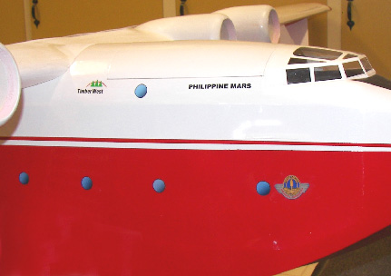

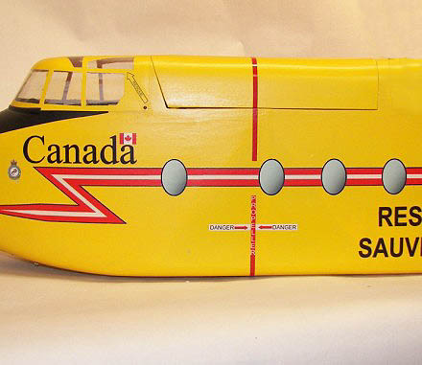

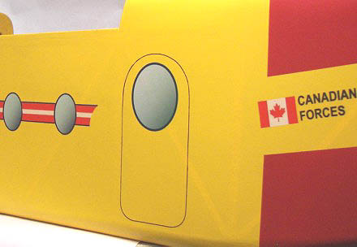

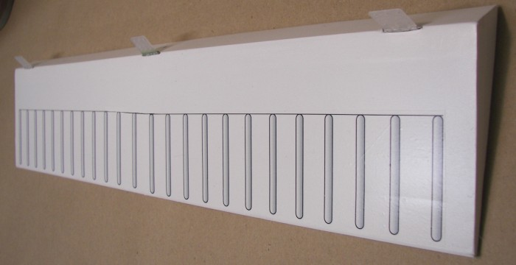

Not only windows.....here I have made slats on this aileron by the same method. The color of the aileron is white so I made the slats on white decal paper. There are 12 slats on a single decal.

