Strip-Plank like a Pro

By: HENRY HOLCOMBE

Scale modelers often deny themselves the pleasure of building their favorite airplane because they are afraid of the planking that would be involved. Others find alternative ways of accomplishing those elegant but often complicated shapes common to so many scale models. But I maintain that when proper techniques are used, planking is the fastest, the easiest and the lightest method of all. The plain truth is that many modelers avoid planking simply because their first effort—often their last—was a mess; the planks didn’t fit; some planks were higher than others; and there were gaps that had to be tediously filled with little splinters of wood and great gobs of filler, followed by hours of sanding to a decent shape. But, it doesn’t have to be that way, as I will show.
The motor nacelle shown here is one of two that I planked for my scratch-built, electric-powered F7F Tigercat. It is 12 1/2 inches long and weighs only 1 ¾ ounces. Circumferences are 13 inches at the nose, 16 at the middle and 6 at the tail. Its double curvature made sheeting out of the question. After I had constructed the frame, I spent only one evening planking it. If you want the job to go smoothly and be hassle free, you must first strip precise planks. Don’t let the word “precise” scare you. Using the techniques shown here, it is easier than you think. The first thing you must do is modify your stripper. I use a Master Airscrew stripper because I have found it to be the easiest to modify for this purpose. Be careful how you adjust the blade; it shouldn’t dig into the work surface. This is true with any kind of stripping. Loosen the setscrews that hold the blade, then rest the stripper on a hard surface, preferably metal. Let the tip of the blade barely touch the surface; then tighten the screws. Don’t worry about the blade not cutting completely through the balsa; it doesn’t have to, and you won’t leave any cut marks in your work surface. The drawing illustrates the end view of the planks after they’ve been stripped and shows the method used to arrive at this shape. Strip all the planks at once, swiveling the balsa sheet back and forth, end for end, as described under the drawing, strip as many planks as you think you will need.
After each pass of the stripper, turn the main balsa sheet 180 degrees (do not turn it over). This will result in shape “A.” The first cut from the main sheet will look like “B.”
Use a plank with cut “B” where a flat surface meets a rounded one (there weren’t any flat surfaces in the nacelles I created). All succeeding cuts will look like “A.” Be careful not
to cut a parallelogram like “C”; this plank is useless for precision planking.
You may think that cutting wider planks will make the job go faster … wrong! Wide planks are harder to fit and they lack the necessary flexibility for precision planking. You see, the planks must bend, not only lengthwise over the end-to-end curve of the nacelle, but also sideways to butt snugly against one another. The planks in my Tigercat nacelles are 3/8x3/32 inch. If you’re planking a smaller form, go down to 1/4 inch wide.
Above: A planked motor nacelle. This technique is light, strong and easy. Below: The frame is ready for planking. The work will go much faster if you estimate the number of planks you’ll need and cut them all at once.

Because you must squeeze and hold each plank in a sideways bend to mate it with its partner, any glue other than CA will take too long to set. Use CA, but not much. With the perfect fits made possible by the side taper of the planks, you won’t need much; think light. Be careful that the taper on each successive plank is properly oriented to its neighbor before you glue it. The last strip is the one that separates the men from the boys. Take your time. Nine strips are in place. To avoid warping the frame, start with the center strips on each side. I started with the two side center strips, plus the bottom center strip. It is important to alternate between an upper and lower plank as you glue them in. Note how the strips are bent sideways. This is accomplished by squeezing them firmly together until the glue sets. With strips wider than 3/8 inch, this sideways bending would be difficult, if not impossible. Eventually the strips will come together at the small end of the nacelle, with a small triangular opening between them. If they don’t, cut a narrower strip to make it so. When you finish, almost no filler should be required. If you do add filler, it will only be because you are seeking absolute perfection. And you may not believe it—until you try it—but with this technique, perfection is possible.

At this point, you must cut an angle on the end of each plank to make it fit at the small
end of the nacelle. The plank in the photo has been marked for cutting. If you measure the length of this cut, you will find that you can cut the ends of several additional strips and they will all fit. Use a steel straightedge to mark the cuts.
Top: The end cuts are marked so that you can see that they are all about the same length. This will be true until the planks come together at the large end of the nacelle. Now it’s time to install the last two planks.

Bottom: I neglected to photograph the next-to-last plank before installing it, so I made a duplicate and placed it above the nacelle. Note that the cuts on each end are identical. The remaining opening in the nacelle tells the story of the last plank. Here you will need to do some sanding. Tip: work on one end until it fits snugly, then work on the other end. Press the plank in and glue.

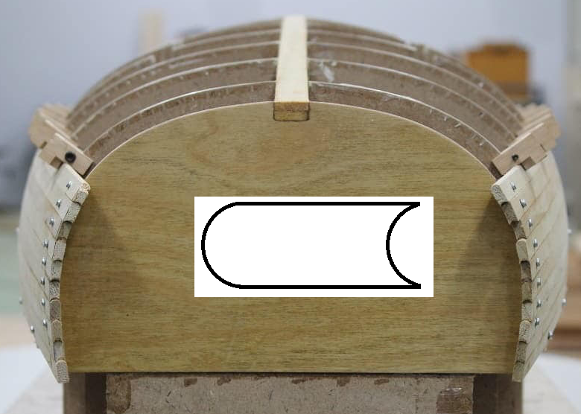

Another way of cutting planks with a router.

