SPARK IGNITION FOR FOUR-STROKES
By Ray McDougall
I have been running spark ignition on all of my four-strokes for many years with great satisfaction. I have often wondered why the big engine manufacturers don’t supply it. Well, it looks like Saito was the first with their new 220 FG and more models are following every day. They run on spark ignition and gasoline. When the buying public finds out how good this system is I think it will inspire the other big manufacturers to go that way too. Let’s face it; the glow system is a very crude system. Most beginners (and some experienced flyers as well) have trouble mastering the required techniques to keep the glow engines reliable. I don’t know of any other commercial engines still on the old glow system. To me reliability is everything and I often wonder why we subject our expensive airplanes to such a crude system. Spark ignition offers huge improvements to what we are used to......

How does it work?
There is no glow plug; instead there is a miniature sparkplug which is fired by a capacitor discharge module. It fires the fuel / air mixture at exactly the correct time in the cycle and is not dependant upon heat and pressure to fire the fuel mixture like a glow engine is. The system is therefore much more reliable and efficient......no longer affected by weather, humidity temperature etc. There is a small magnet mounted on the rotating prop hub and an electronic sensor (Hall Effect Sensor) fixed on the crankcase. Each time the sensor passes the magnet a high voltage charge is sent to the sparkplug from a capacitor (capacitor discharge). Power is from a 4.8V battery pack. The spark module also senses the rpm of the engine and advances or retards the spark timing to the changing rpm. of the engine. The timing is adjustable.....you can even use an automotive timing light and see the advancing of the spark as the rpm is increased. It is uncanny to watch this.....it looks like the propeller is standing still in the flashing light!! It is well known that the exact timing of the spark has to change throughout the rpm range. Glow engines do not do this effectively. Most all modern two-strokes use electronic spark ignition.....there are few magneto engines made any more. The big difference is that the electronic system advances and retards the timing......the magneto system does not.

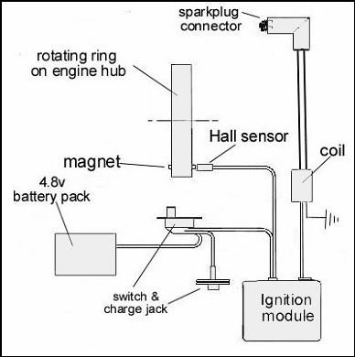

The drawing shows the general layout of a typical system. There are a number of suppliers, some of the parts are available locally and some can be fabricated. The installation is not difficult although some of the small parts such as the mounts for the sensor and magnet need to be fabricated.

What are the advantages?
Reliability; Because the ignition system fires at exactly the right time-every time, there is no possibility of prop kick-back.....one can safely start the big four-strokes with bare hands. The detonation takes place at idle after TDC so there is no pre-detonation regardless of throttle position. The engine will start easier and idle at around 1000 rpm RELIABLY!! It will not be affected by weather or temperature changes.....Today’s carb settings will be there tomorrow.
More power; Just the fact that the engine fires at exactly the right time in all conditions contributes to an increase in power. Fuel is burned more efficiently.
Cost savings; Spark engines do not like high oil and nitro content. I mix my own and use only 10% nitromethane and only 14% Klotz synthetic oil. Some say you can go as low as 10%oil and right down to zero nitro. Of course the fuel cost is 'way down.....It costs me about $13.00 per gallon to mix. If you can’t find the components you can cut down regular glow fuel with methanol to get the percentages that you want. Methanol is easy to find (methyl hydrate). The other bonus is that I always have exactly the same fuel and I don't have to depend on the retail stores that carry it (and often don't have what you want). The cost is further reduced because the consumption falls to about half of what would be used on glow. As an example, it takes fourteen turns of my pump to fill up after a normal ten minute flight with my Saito 80 on glow......It takes the same number of turns to fill my Saito 150 tank with that engine on spark ignition.....that represents about half the fuel consumption!!. This also means that a smaller fuel tank can be used for weight saving.
Clean burning; There is little or no oil all over the fuselage like is common with glow engines.....I guess because the firing is so efficient that there is almost no oil residue, it is probably all burned up. I wipe my planes down about every third trip to the field.

What about using gas?
Many attempts have been made to convert to gasoline instead of methanol however our common four-stroke methanol carburetors do not work well with gas. The jetting for glow fuel is all wrong for gasoline. I think methanol produces more power than gasoline anyhow....that's why they use it in race-cars. So I stick to the common glow fuels. The new Saito uses a Walbro type gas carburetor.....quite different to the glow carb. The new Saito gas / spark models are not easy to adjust.....very fine jet adjustments are necessary. I prefer the standard carb with glow fuel.

What are the down-sides?
I have found only one disadvantage..... all of these systems will produce significant RFI emission (glitching), which, of course, can be a serious problem if not looked after. The system will be sensitive to flying wires, location of battery packs on the airplane and other metal masses. It is necessary that the spark system and the receiver system on the aircraft be placed as far apart as possible (at least a foot apart) and a proper range test be carried out after initial installation to ensure that there is no RF interference. The new 2.4 radio systems are much less sensitive to RF than the old 72 systems. You will also need a second battery pack; the receiver pack is not enough. I use a 1000mah or larger nicad or nimh pack so there is a little weight added here.

Where do I get them?
These systems are available from;
CH Ignitions http://www.ch-ignitions.com/
Pro Spark http://www.nelsonhobby.com/prospark.html
Ridge Machine http://www.dandbengines.com/ignitions.html
RCEXL Canada http://www.prcmodel.com/modeng/name/onlinestore/category/7
RCEXL USA http://www.cncengines.com/rc.html
SDS Hobby http://www.sdshobby.com/

There are others. Each one is basically the same system but there are small advantages to each. In addition to the spark unit you will need the 4.8v battery pack, a magnet and a ¼ X 32 spark plug. Check out the supplier’s websites for more information.

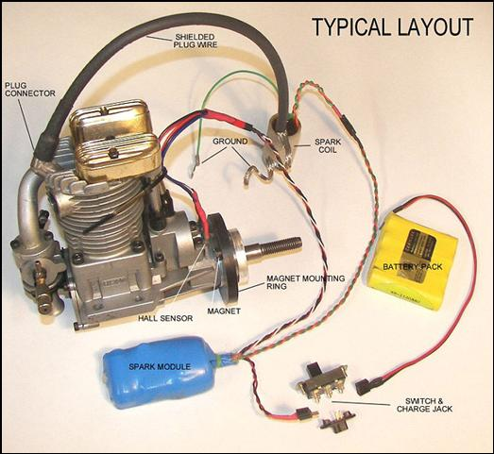
The small parts.....the aluminum brackets to hold the sensor are not usually supplied with the spark system, I fabricate these small parts.

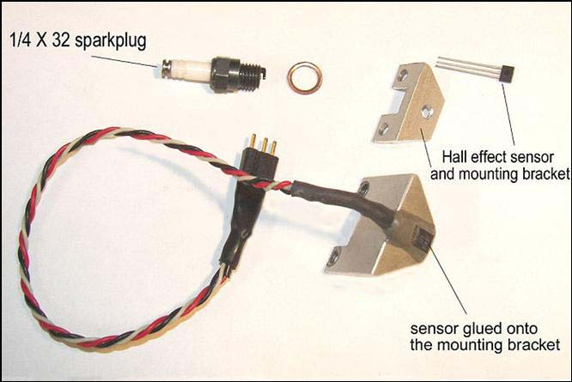
The above Hall Sensor mount is hand made.....the sensor is glued to the aluminum mount with JB Weld. It is made to be used with the fibre magnet mounting ring shown in the first photo.
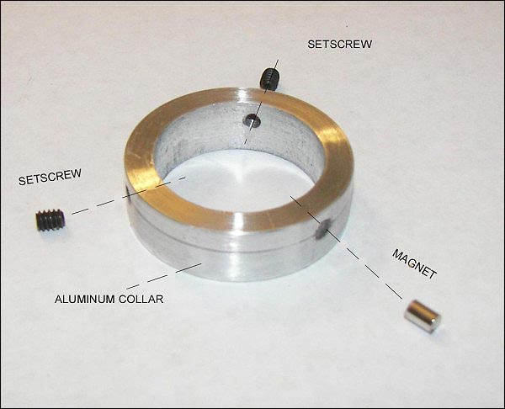
An aluminum ring can be made on the lathe as shown above. A different shape sensor mounting bracket is required in this case but easy to make. It is possible to drill the factory Saito prop drive washer and install the magnet directly in the drive washer but I don’t recommend it......One needs to be able to adjust the timing of the spark and therefore some kind of moving magnet or moving sensor is necessary. I find it easier to make the magnet adjustable on the drive washer by fabrication a ring as shown below.....Remember the Saito drive washer in not mounted on a crankshaft keyway.....it is on a tapered collett and can lose it’s orientation to the crankshaft easily. By using the ring as shown the timing can be easily adjusted.
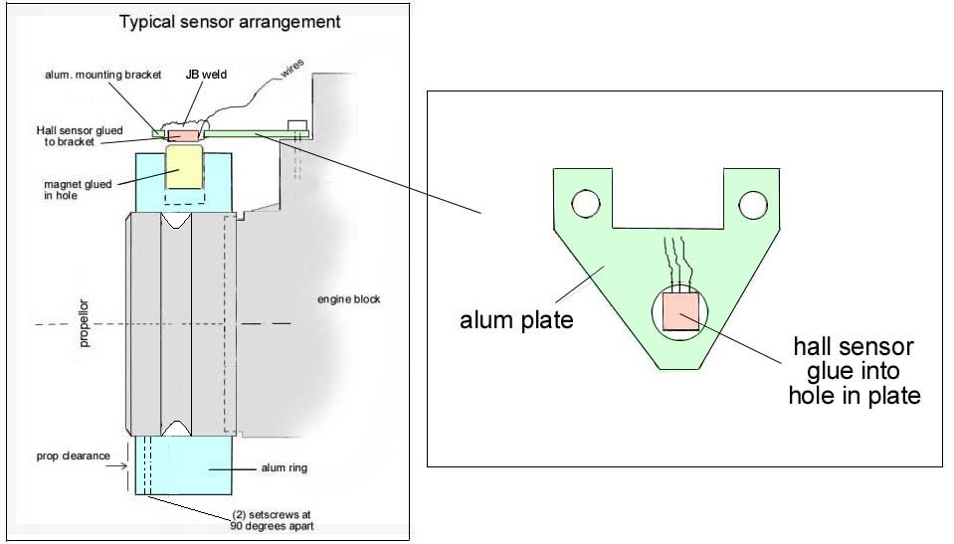
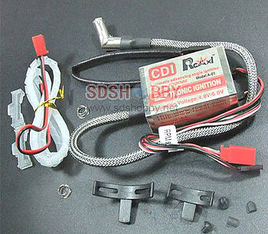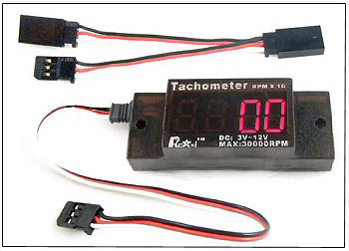

This complete RCEXL ignition conversion kit is available for four-stroke glow engines from SDS Hobbies at $43.42. It includes the module, Hall sensor and mount, ¼ X 32 sparkplug cap and the Hall sensor. You need to add a sparkplug, battery pack, a magnet and a mounting ring for the engine drive hub. The Mini-tachometer shown at the right can be plugged in between the Hall sensor and the ignition module. It will read out the RPM accurately even under overhead indoor lighting where a normal tachometer will not work. It is safer to use than a hand-held tach and sells for only $9.95
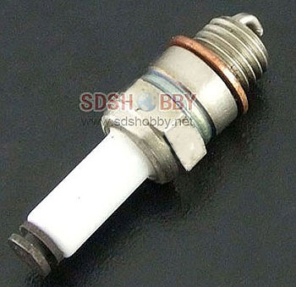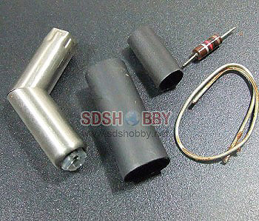
The above ¼ X 32 sparkplug is $9.08 and works better than the American made plug which is prone to breaking of the porcelain top and is three times the price. If you need to make up your own sparkplug connector the above kit sells for $7.35 and can be assembled at home as long as you have some soldering skills.
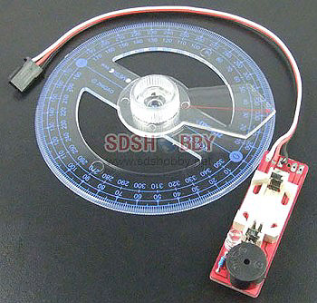
This degree wheel with the spark sensor is made to adjust the spark advance setting. It is slipped over the drive hub of the engine and the pointer set to the recommended advance. When the engine is rotated by hand the electronic module sounds a buzzer and flashes an LED. It shows the exact point at which the spark occurs. It allows you to set the exact static timing point. A very useful item at only $5.98
Jan 2012

