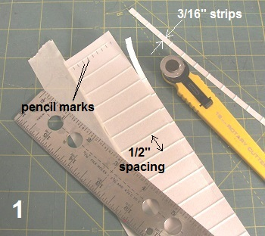

**SCALE RIB STITCHING**

The process and dimensions shown in this article are my personal preferences for ¼ scale stitching.

1. The stitching tapes come from ken Kosmenko at *Scale* *Rib Stitch.* The string stitching comes on sheets of adhesive backed paper 2” wide by 36”long. Stitch spacing is ½”. You will get about 11 strips 3/16” wide from each sheet. Cut the stitching strips with a roller knife keeping the width as accurate as possible.

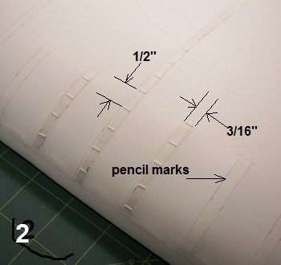

2. Mark the exact location of each strip where you want it on the surface to be taped with a pencil. Peel off the paper backing of the stitching strip and place the strips on the pencil marks.

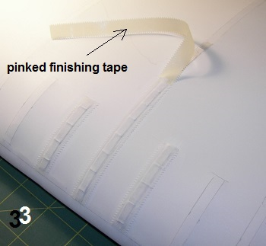

3. The pinked covering tapes come *from Dynamic Balsa.*

I like to use the 3/8” wide tapes for my ¼ scale models. The pinked tapes come in rolls of 90ft or 180ft X 3/8”. The pinks are 16 to the inch. The pinked tapes may be ironed on or applied with trim solvent. I like to wet the tapes with trim solvent with a brush and press them down onto the surface…..let them dry and finish ironing the edges with the trim iron.

4. The finished product, in my view, is very good using this process.

Ray McDougall

<http://www.raysmodels.ca/>

