PRE-SHADING FOR REALISM
Ray McDougall

For a long time I have struggled with attempts to create very real looking panel lines, rivets and weathering on my scale models…..I have followed the advice of the experts and, sure, some of the techniques work OK but there is always something missing. To identify exactly what is missing is the tricky part. If these surface details are applied perfectly to scale [size of rivets, panel line thickness etc.] they don’t always look right. Weathering can look awfull if it is overdone. I don’t think it is reality that we are seeking, rather, it is a perception of reality that we are looking for. Sometimes there is a very good effect achieved where the actual details are nowhere near true scale. Panel lines, for example, don’t jump out at you when you are looking at a real airplane from about 25ft. distance…….in fact one can hardly see them. If we look at or photograph a real aircraft and study what we are seeing very carefully it becomes apparent that there are subtle shadings, color differences and shadows on the surfaces…..some surfaces being very dark and others light, depending on the light conditions. When we look at the typical model from relatively the same distance [5 to 10ft.] we see all one shade of color and the panel lines and other small detail stand out like a sore thumb. A model covered in white Monocoat, for example, appears stark white on all of the surfaces…..the same uniform blank white is seen on photographs of the same model as well. What I have been looking for is a way to create this feeling of subtle shading on the finish of my models.
What I have found looking at some very interesting plastic modeler’s websites is a technique referred to as “pre-shading”. Clearly the plastic modelers are away ahead of us glow guys on fine detailing and attention to scale…..they know a lot about painting and the special effects that can be achieved. Pre-shading is a technique of lightly “fogging” a darker color over panel lines and rivet lines before the final color coat goes on. The last few color coats are applied quite transparent until only a faint shadow of the darker undercolor remains visible. More about this process can be found at www.hyperscale.com ……look under “feature articles” or use their search feature to find “preshading” there are hundreds of fine finishing examples. Here is how Roger Fabrocini Explains his process along with a couple of photos…..
After priming the airframe with 'Mr. Surfacer' 1000, I pre shaded with a brown-black mix, not only following the panel lines, but also painting in ribs and spars. My color coat is then applied in a very thin mix first over the pre shading then moving into the panel interiors. The very thin mix allows me to slowly add color and still let the pre shading show through. Successive color coats are applied using lighter and thinner paint working into the panel interior. I find it very important to keep the paint very thin or a distinct separation will be detectable between the color coats making the effect look unnatural.

continued

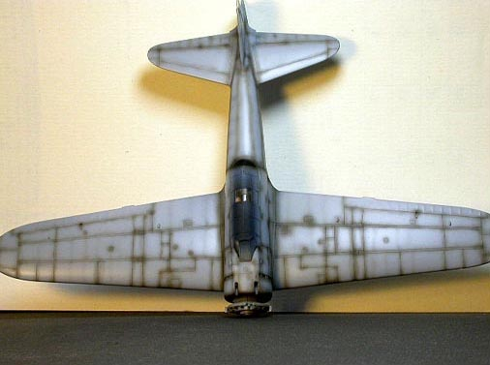
Roger's Zero with preshading applied
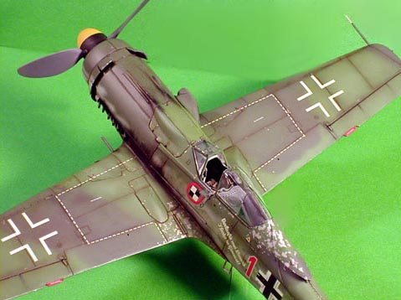
A Focke Wulf by Doowan Lee finished 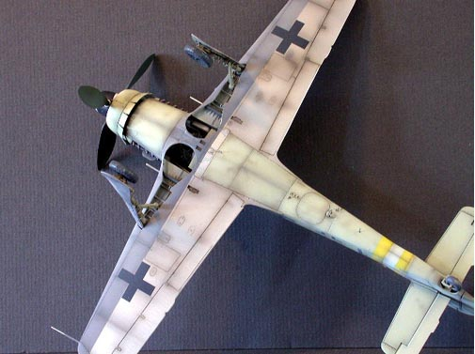
Another good example of the finished effect
I am told there is a very good book available on the pre-shading technique by Brett Green, the guy who coined the name and owner of the website..... the book is ."Modelling the Messerschmitt Bf 110". There is also an article on the same technique by Russle Fielld.

