Casting in Resin

Plaster of Paris casting never worked for me.....it was messy, the plaster sticks to the mould and it tends to crumble and fall apart. Casting using the special polymer products is too expensive and the possibilities are limited. My first attempts at casting with a rubber lined mould worked out very well. The process is a little difficult to understand at first but simple once you are familiar with it. Use your imagination to think of the many possible applications in our hobby.....It’s the only casting process that I know of that will accommodate considerably pronounced undercuts.....no join line is left on the finished casting. Its fun to do and not expensive either. The process is described as follows;

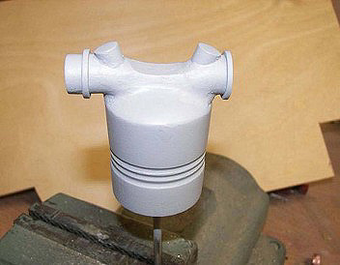

1. Make the plug;.....in this case a dummy cylinder for the Daimler engine in my Hansa Brandenburg. I need six of them. This plug was made from wood, metal bits and auto body filler, it’s sanded and painted with grey primer. The final product will be six identical cylinders cast in plastic resin.

2. Coat the plug;.....The plug is first mounted to a small piece of plywood then painted with seven coats of rubber latex to get sufficient thickness of rubber. I get about three coats a day onto the plug leaving time to dry in between coats. The latex can be purchased at your local crafts store, it’s inexpensive, non-toxic and cleans with water. The official name is Water base Latex #704. It is air-cured and contains high solids.

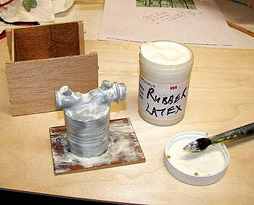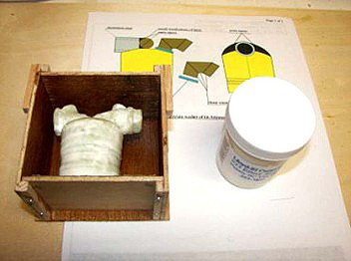

3. Make a box; to contain the latex coated plug. The box can be quite crude and made of cardboard or scrap plywood, in some cases it only needs to be a “dam” to contain a lump of plaster. The plug must be supported within the box so that there is about ¼” clearance around, below and above the plug....we are going to pour plaster into this box. It helps if the box is made to disassemble easily, it can be used again for future projects.

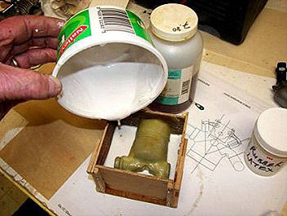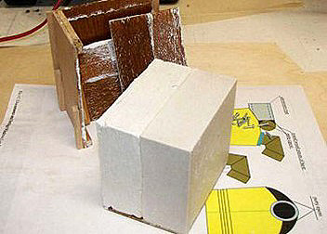

4. Pour the plaster; Don’t use Plaster of Paris.....it’s much too crumbly and does not have any strength at all. Use #1 pottery plaster, mix it to a pourable slurry or to the proportions; 60% plaster / 40% water. This plaster is strong and clean when cured. We will be pouring the plaster in two stages.....First pour until the level of plaster comes exactly half way up the plug, this when hardened will form one half of the mould. The plug must be located so that the plaster will come off the plug (no undercuts). For some shapes you may have to make three or more plaster sections. This plaster mould is only to back up the rubber shell which otherwise would be too “floppy” to maintain the correct shape. The plaster will take about 20 minutes to set up and a day or so to become completely hard. After the first pour is dried, brush or spray on mould release before pouring the second layer of plaster.....the second pour will fill the box. I used “mould soap” as a mould release for the plaster work.

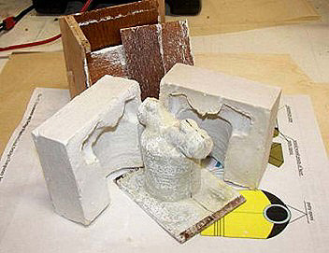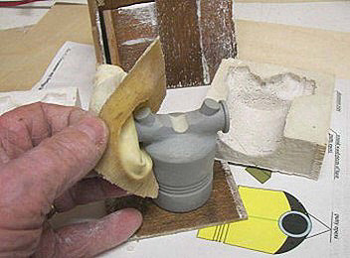

5. Remove the plaster halves; When the second pour is hard break the two plaster halves from the box and clean off the edges and any lumps of stray plaster.....these two plaster halves must go together cleanly later on.

6. Strip the latex from the plug; Now very carefully peel the latex skin off the plug. This is the finished mould surface so keep it clean and be very careful not to tear the latex skin, if it does tear you will know that the latex was not thick enough and you will have to start over again from the beginning. The latex skin can be ”rolled off” in which case it will be inside-out.

It can easily be popped right-way around again. At this point we are finished with the original plug and the box.

7. Reassemble the mould; With the plug taken out, reassemble the two plaster halves with the latex skin inside.....before doing this lightly coat the inside of the mould with mould release. There are probably many release agents that can be used.....I used “Synlube 531” in a spray can. Hold this together with a couple of elastic bands. This is your finished mould ready to pour the resin cylinders. Note that the rubber mould and the plaster must be completely cured before pouring. If the plaster is thick it can take up to a week for it to cure.

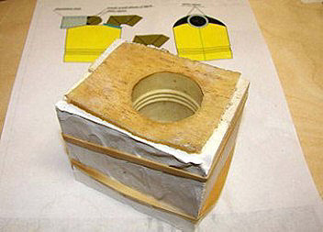

8. Pour the resin; Now the resin can be poured into the open base of the mould for your first cylinder. I think that any kind of resin or epoxy will do with the correct mould release. I used “Pour-A-Cast Mark 3” by Synair. When the resin is hardened the plaster halves are separated and the latex skin peeled off the new resin casting. The rubber and plaster mould can be used again and again. Properties of the resin can be found at;
http://www.liquidplasticsolutions.com/synairproducts.htm

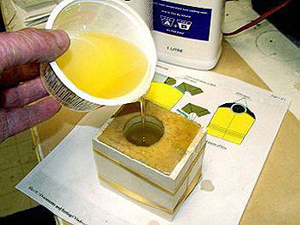

9. Peel off the rubber when the resin is cured like you did before and TA –Ta!!.....There is the finished product......now I’ll make five more of these.

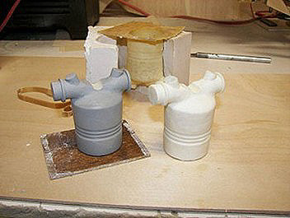

Some other exciting possibilities; The finished product can be cast hollow. If weight is going to be a factor there are two possibilities to reduce weight.....first is to mix microballoons with the casting resin before pouring. The second possibility is to simply dump most of the casting resin out of the mould at a critical time when the resin is starting to thicken. This way there will be a thin coating of resin left inside the mould, the casting will be mostly hollow. The thin walls should be strong enough for most purposes.The casting resin can be colored with pigment before pouring. Mixing gold, silver or brass powder with the resin will result in a metallic looking casting.....very cool !!

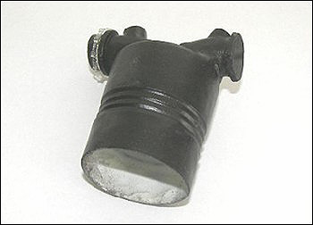

Here are some very tiny tappits made with this system, the photo shows the metal plug, the rubber mould and the finished resin tappit as it popped out of the mould.

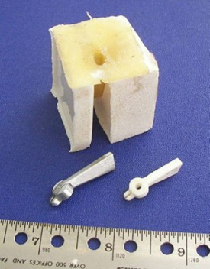

The finished engine is shown here......You can see the cylinders and tappits on the engine.

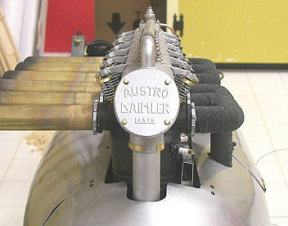

by Ray McDougall 2009

