BIPLANE RIGGING

My biggest beef with biplanes was the time it took to assemble and disassemble the wings and rigging wires at the field before and after flying.....it got so that I hated to take them out anymore. I had to find an easier way.

What worked for me was a system of pinning the outboard struts in place with metal pins going into sockets in the wing. I used a big pop-rivet to do this.....I pulled the pin out and epoxied it into the bottom of the strut leg. The aluminum base of the pop-rivet was epoxied into a block of hardwood in the wing. The strut simply slipped into the holes in the rivet body.......This is very quick to assemble.....simply stand the strut in the lower wing holes and drop the top wing onto holes in the top of the strut. The difficulty here is that there is nothing to hold the upper and lower wings together on the struts. I overcame this by hooking the two wings together with a piece if flying wire and a spring with a hook on it. The spring tension is enough to hold the upper and lower wings together on the strut. The little hooks came from downrigger gear, available in fishing supply stores. When the spring loaded wire is unhooked the struts just fall out of the holes. Of course the pop-rivet pins and body need to be carefully aligned before they are epoxied in place permanently.

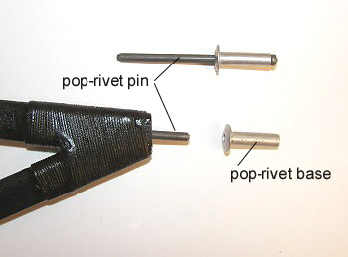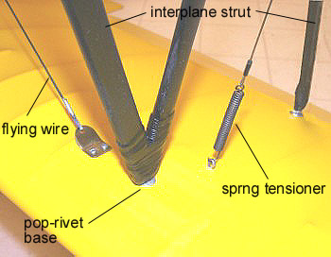

I have both upper and lower wings made to slide in place on wood or carbon dowels and the flying wires hold everything tight and in place. I use the little hooks wherever possible to avoid bolting. To accomplish the final tightening of all the rigging only one turnbuckle on each side is required and it does the final job of tightening everything up and holding the wings into the fuse on the dowels. Don’t forget to wire the turnbuckles or they will come apart from vibration. When the turnbuckles are
Tightened nothing can move.

The assembly (and disassembly) is very quick.....It goes like this;

1. Plug the wings into the fuse and center cabane on the dowels.
2. Spread the wings apart slightly at the tips and slip the outboard struts into the sockets.
3. Hook up the spring loaded wires on each side.
4. Hook up the flying wires using the little hooks.
5. Do up the single turnbuckle on each side.....DONE !!

2.....

2.

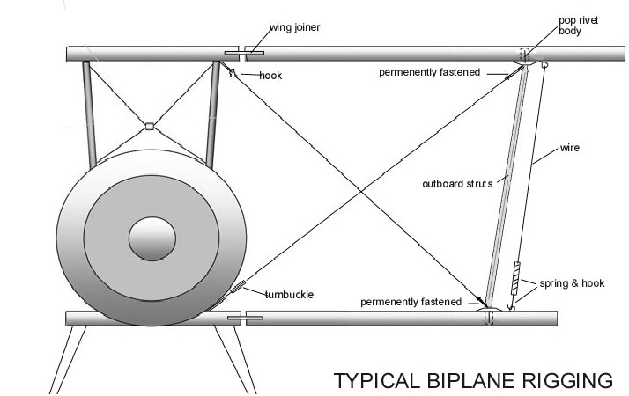

Ray McDougall 2010

