FUEL PUMPS
author unknown
All Saito engines (at least those sold in the US) except one version of the 300 twin, use muffler pressure with no pump. A pump will provide uniform fuel flow from full to empty and in some cases permit placement of the tank near the center of gravity of the model. However there is no need to use a pump if you have a tank just behind the engine near the same level as the carb, and the tank is not greatly oversize; the engines work very well like this with muffler pressure alone.
If you are a new flyer, or just fly slow scale models, you would have no need to consider pumps; the standard Saito setup as explained in the engine instructions booklet with muffler pressure is fine and trouble-free; use a fuel tank that is an appropriate size, with a location close to the engine, use muffler pressure, forget pumps, and don’t bother with the information on this web page --- you will likely be very happy. On the other hand if you have an unusual fuel tank setup, or want very reliable fuel flow for extreme aerobatics this page might be right for you. A properly setup pump can provide extremely reliable and consistent fuel delivery. A pump can make an already well-setup engine even better, but it won’t cure basic engine problems such as carbs that leak air, blocked filters, kinked fuel lines, etc.
1. Fuel Regulators
(a) The Cline Pressure regulator: This is not actually a pump but a pressure regulator and a good option instead of a pump or straight muffler pressure. I have used it successfully. This works fine although it can be confusing for some people to set up. A one-way valve is used in the exhaust pressure line to increase the tank pressure to a value of a few pounds per square inch; the tank pressure needs to be at least 2 pounds. A pressure regulator is inserted in the fuel line just before the carb. The function of the pressure regulator is to allow the engine to draw fuel as needed. The advantage is that the tank position is not critical. The disadvantage, although not major, is that the tank is pressurised at fairly high pressure and if something goes wrong with the pressure system, (eg pressure line comes off muffler) then the engine will probably quit. The plumbing is somewhat more prone to failure in my opinion compared to other options. I instead prefer the Perry pumps as they do not require a muffler pressure line, however the Cline system is an excellent method if you want the tank back at the center of gravity far from the engine. The Cline system is a good option if you want to place the fuel tank back near the center of gravity. If you want more information on this option check out this URL: http://www.billsroom.com/pcfs/fuelsysdesc.htm
(b) The Iron Bay Regulator: This works the same as the Cline system but is made by a different company. A difference is that the line from tank connects on to a fairly large diameter nipple on the regulator; this is probably an advantage if you want to use large diameter tubing (eg 5/32 ID) from tank, but a minor disadvantage of you want to use thinner tubing (eg 1/8 ID), however the Sullivan tubing adapter can easily solve that problem (see picture below). The Iron Bay web site is
http://www.ironbaymodelcompany.com/Webpages/Accessories/Accessories.html
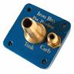 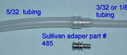
2. The Perry VP-20 Oscillating Pump: I have used this pump with the 50, 56, and 91 engines and seen it work fine with a 150. It can be mounted on the firewall just behind the engine provided you don’t use a very soft mount, and it is not necessary to use the mounting plate provided with the pump If a very soft engine mount is used the pump should not be mounted on the firewall; in this case the pump should be mounted on the engine, or part of the engine mount that vibrates with the engine, because the pump uses engine vibrations as its power source. The best place to locate the pump in my experience is horizontally, parallel to the ground, on the firewall just behind the engine, about 2-3 inches below the crankshaft level. If you choose this pump the tank is best located just behind the engine, although I believe it should pump from a longer distance. The advantage of this pump is the uniform mixture from full to empty tank. It is useful in certain scale model designs that do not permit locating the tank near the same level as the carb. There is a pressure adjustment on the pump. You should first run the engine on muffler pressure. Then after connecting up the pump readjust the main needle valve; if it is more than about 1/2 - 3/4 turn different from when you had muffler pressure then adjust the pump pressure appropriately so that the main needle valve setting is within 1/2 turn of the situation when you had muffler pressure alone. I have successfully used this pump both with and without muffler pressure, although the instructions do not suggest using muffler pressure with this pump. If you do not use muffler pressure with the pump the vent line to the tank must be open to the atmosphere.
3. The Perry VP-30 Pressure Pump: This is a pump and regulator driven by pressure pulses from the crank-case. A short (abour 2”) length of fuel tubing is connected from the crankcase breather to one arm of a T-joint, The other arm is connected to about 4-6 “ of fuel tubing and is left open to the atmosphere. The remaining open line on the T-joint is connected to the pump pressure input via the red tubing that comes with the pump. The adjustable knob on the pump should be screwed almost all the way in to maximize fuel flow; do not force it too much, just screw it in until it almost reaches the end. For the newer pumps that are adjusted with a hex tool, turn it in until the top of the screw is flush with the top of the plastic pump body. Note: When using this pump, the tank vent must be open to the atmosphere, and no muffler pressure is used. The crankcase remains open to the atmosphere for excess oil to drip out.
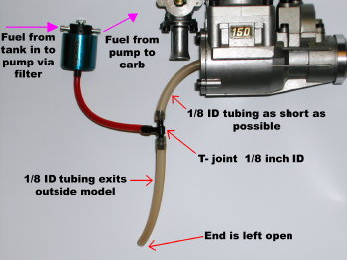
The T-joint should have 1/8 inch inside diameter (or larger). The red plastic tubing from the pump to T-joint is supplied with the pump; it helps to heat the end of this red tubing with a heat gun to get it onto the T-joint.
Here are examples of some setups that have worked for me with the Perry pressure pump.
- Saito-91, engine inverted, 1/8” tubing everywhere, standard tank that came with the kit (a Kyosho Sensation). Tank located back over the CG.
- Saito-120, engine upright, 1/8” ID fuel tubing everywhere, standard unmodified 18oz Graupner tank. Model is a Sig 4star-60. Tank located back over CG.
- Saito-150, engine side mounted. Standard unmodified 18 oz Graupner tank located up front just behind firewall. 1/8” ID silicone tubing from tank to pump and pump to engine.
When setting up these pumps, check for air bubbles going into the carb from the pump. If there are no air bubbles going into the pump but air bubbles coming out the pump, the pump is leaking and needs replacing. If you find that the engine is too lean at full-throttle, and you can not richen it up sufficiently with the main needle valve, the pump may not have sufficient fuel flow; in this case the pump also needs replacing. In the unlikely event you have a defective pump, I suggest sending it back to Gary Conley for a replacement. I have spoken with Gary and he is dedicated to provide a quality product. All the pumps now produced are rigorously tested before shipment.
A problem with these pumps can be finding a place to mount them. Below is a Saito-120 in a SIG Four Star-60 model. The pump is mounted on the side of the model (not too elegant). You can see the fuel filter (on the pump input line) mounted on the model adjacent to the engine. The pressure inlet to the pump is the red tube that goes through the hole in fuselage to the T-joint inside behind the engine. The model has the tank located at the center of gravity position over the wing. This setup has worked very well for over five years without ever adjusting the pump or carb. The pumps don’t seem to wear out and provide very reliable fuel flow. They are my favorite because the tank remains unpressurized and no muffler pressure tap is required.
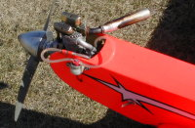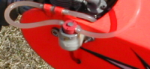
The photographs above show a Saito-120 in a SIG Four-Star-60 with a Perry VP-30 pressure pump mounted on the side.

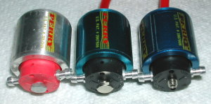
The above picture shows three versions of the Perry pump. The one on the left with red plastic and silver body is the original version made by the Perry-Varsane company. Later Conley Engines began making these pumps and changed the external appearance (see pump in the middle of the above picture) to have black colored plastic and a blue colored body. Both the original red Perry pump and the early Conley versions used a hex shaped adjustment screw. Recent versions (see pump on right side in above picture) use a different adjustment screw. The newer pumps have a screw that is easier to adjust by inserting a hex tool into the screw.

4. The Saito Pump System:
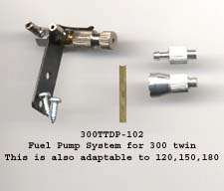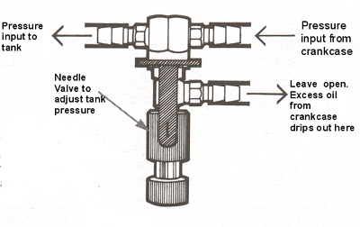
Currently the only Saito engine sold in the US with a fuel pump is a version of the 300 twin. Saito have also made a 120 and 150 with a pump. These were formerly sold in the US but the importer (Horizon Hobby) ceased importing them. I am unsure if they are still manufactured. This is probably only relevant if you have an older engine with this pump system, however since the pump system is available as a separate item it may be feasible to convert a new 120-150-180 engine to use this pump but I have not tried it myself. The system works via tank pressure. The rear crankcase cover has two vent nipples each containing one-way valves. One valve allows fresh air into the crankcase, the other valve is reversed in direction and pumps air out of the crankcase to the tank via a needle valve assembly. The needle valve may be adjusted to bleed off pressure such that the tank pressure may be varied by turning the needle valve. It works extremely well and the tank pressure remains remarkably constant. The difficulty with this system was the abysmal lack of instructions and I suspect most people set it up with too much tank pressure. The needle needs to be turned a long way out so that the tank pressure is no more than about 1-2 pounds (psi). I have found that a pressure of about 0.5 to 1.0 psi is ideal for the Saito-120 and 150. The Saito instructions with these engines suggest the pressure adjusting needle valve should be opened 2 3/4 turns; I have been unable to get these engines to run with this pressure setting and had to reduce the tank pressure by turning the adjustment out about 5 1/2 turns to get about 0.5 - 1.0 psi tank pressure. The actual value of the pressure is not important if the engine runs OK. It is most convenient to measure the tank pressure by temporarily connecting a pressure gauge via a T-joint into the fuel line just before the carb. If you do not have a pressure gauge I suggest turning the needle out about 5 1/2 turns and try it. If it seems way too rich at mid-range try lowering the pressure by turning out the needle about 1/4 turn. If the pressure is too high the mid -range will be excessively rich and the engine unreliable. You should experiment with different tank pressure settings to find a value where the carb adjustments permit reliable engine performance. The usual problem with this pump is users setting the pressure too high. I would appreciate hearing from anyone who has successfully got one of these engines to run with the recommended 2 3/4 turns on the pressure adjusting valve. You can buy the pump package from Horizon Hobby, that contains the pump needle valve assemble plus the two one-way valves; it is Saito part number ‘300TTDP-102’ and is also provided with the pumped version of the 300 twin in current new engines.
Note: Although this system pressurizes the tank from the crankcase, very little excess oil from the crankcase seems to go into the tank. The crankcase is still effectively open to the atmosphere through a one -way valve that lets fresh air into the crankcase, another one-way valve from the crank-case connects to the pump needle valve assembly and most excess oil drips outside through the pump assembly drip tube shown in the above diagram.
For the Saito-150 DP with the Saito pump system, here are my settings that work. Pump needle valve turned out 5 1/2 turns; this results in a tank pressure of a little more than 1/2 psi (Note: 5 turns out was not satisfactory, the extra 1/2 turn is important). Main engine carb needle valve turned out 2 1/2 turns. OS F-type plugs, Byron fuel 15% nitro, 16% oil content (synthetic-castor blend). The 2 1/2 turns out on the main needle valve is a bit rich; and may need changing to suit the particular fuel, weather, etc. The engine has a reliable low idle of about 1800rpm with an APC 16x8 or 17x8N prop..

